Feature: Login to OpenTaps

Scenario Outline: Successful login with South Indian user data
Given I open the login page
When I type "<username>" into the Username field
And I type "<password>" into the Password field
And I click the Login button
Then I should be logged in successfully

Examples:
| username | password | name | address | pin | mobile |
| "ramkumar" | "Ram@1234" | "Ram Kumar" | "123 MG Road, Chennai, Tamil Nadu" | "600001" | "9876543210" |
| "sita.r" | "Sita#2022"| "Sita Reddy" | "45 Beach Road, Visakhapatnam, Andhra Pradesh"| "530001" | "9123456789" |

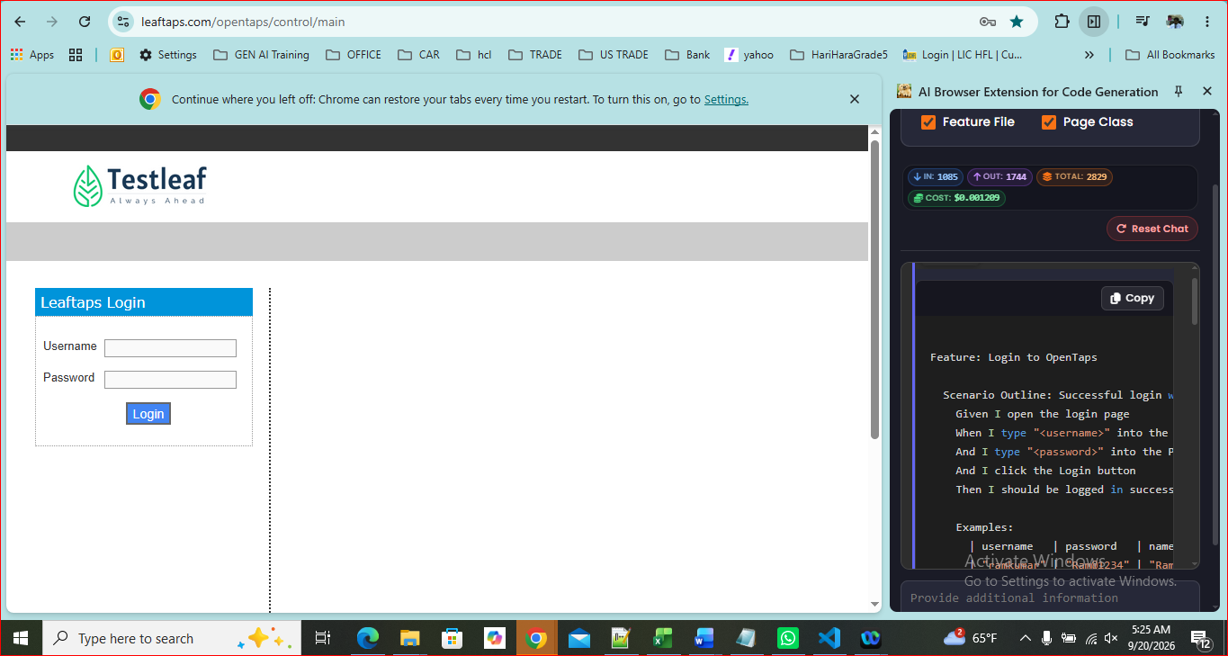
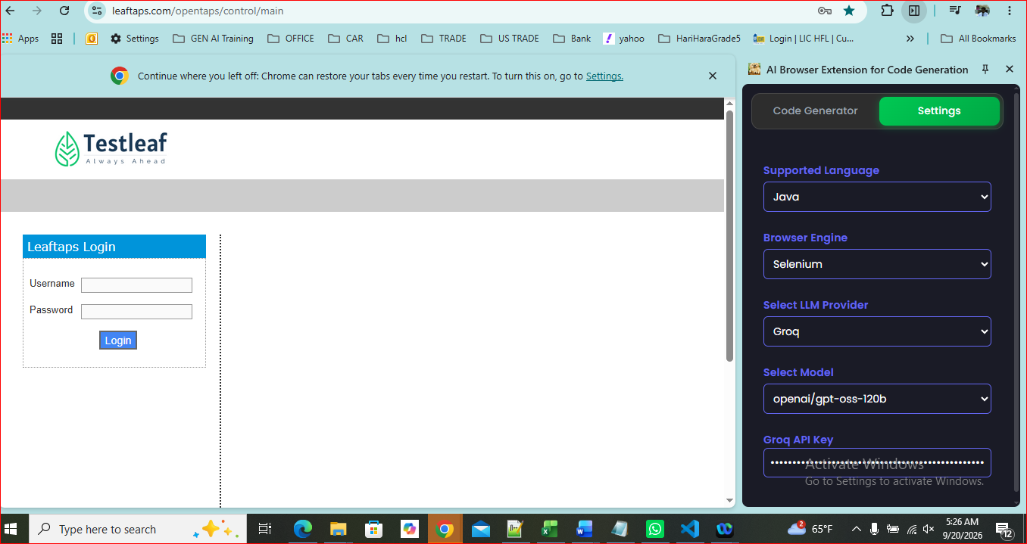
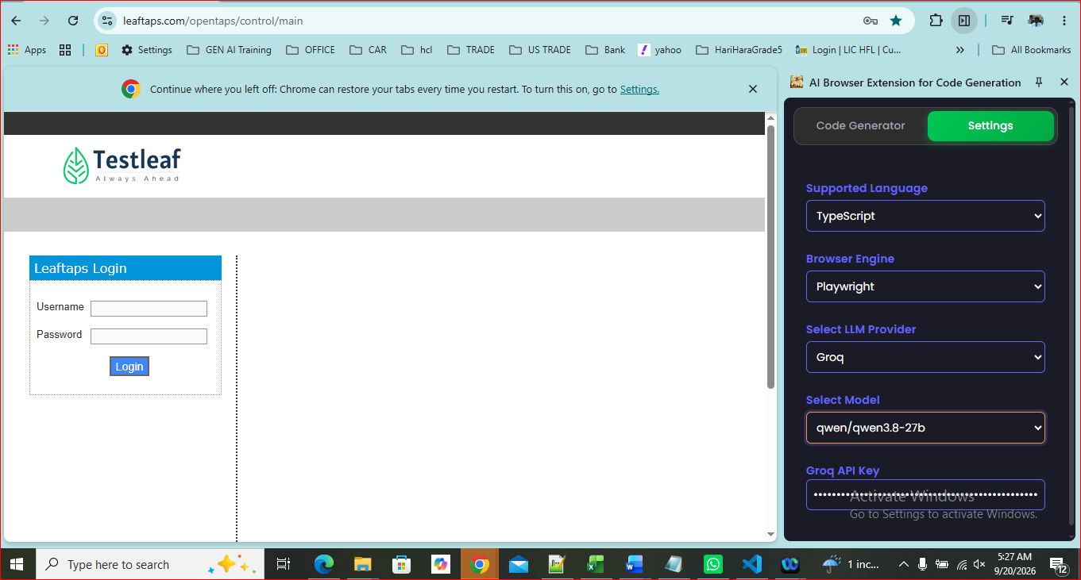
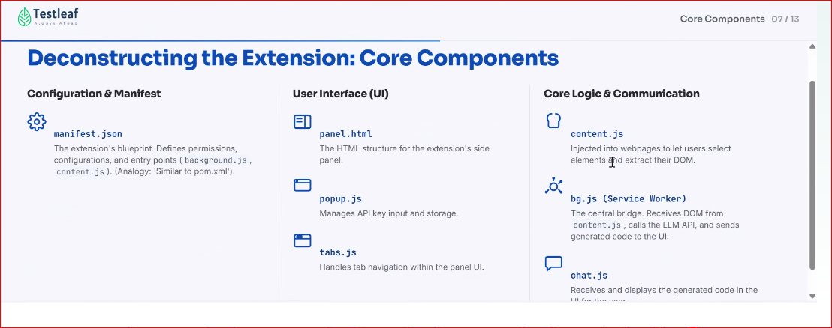
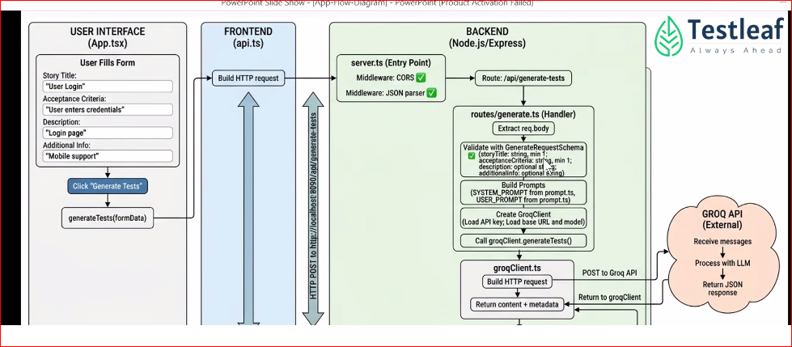
WEEK 4 DAY1

